**CS657 Assignment -2   
Predicting Fake Job Posting**

**Dev Divyendh Dhinakaran  
G01450299  
Tejaswi Samineni  
G01460925**

1. **Missing value Percentages**  
     
     
   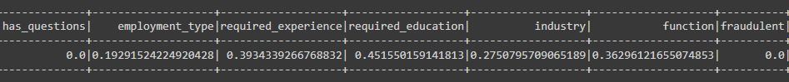
2. **Cleaned Dataset**

1. **Sampled Dataset**

1. **Vectorized Features (Title, Description and along with other columns )**

1. **ML model outputs  
     
     
     
     
     
   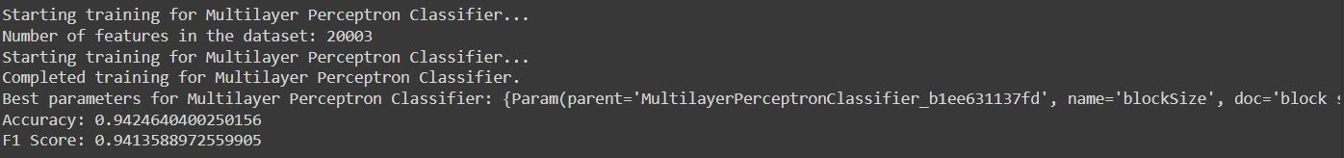**
2. **Metrics Graphs  
     
   A comparison of a graph

   Description automatically generated with medium confidence**

